**GitHub Lab**

In CMSC 203, this lab was assigned. I am sharing it with you as reference materials.

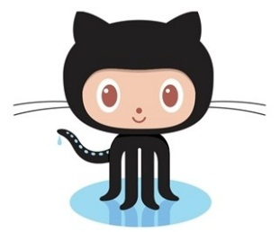**GitHub**

**GitHub** is a web-based [hosting service](https://en.wikipedia.org/wiki/Internet_hosting_service) for [version control](https://en.wikipedia.org/wiki/Version_control) using [Git](https://en.wikipedia.org/wiki/Git). It is mostly used for [computer code](https://en.wikipedia.org/wiki/Source_code). It offers all of the [distributed version control](https://en.wikipedia.org/wiki/Distributed_version_control) and [source code management](https://en.wikipedia.org/wiki/Source_code_management) (SCM) functionality of **Git** as well as adding its own features.

If you have ever edited several versions of a file, you may have added a date onto the file name so you don’t erase the earlier versions. Git was created to manage these versions transparently to you.

You might need to use Git or GitHub on a software development team in industry or government in the future. Therefore, this lab will introduce you to GitHub.

Octocat is the mascot of GitHub. You can see many versions of Octocat at <https://octodex.github.com/>.

* Using Git and GitHub

**Concepts tested by this lab**

* + Creating an account in GitHub
  + Creating a repository
  + Uploading a directory of files

**Lab Description – for students**

We will use GitHub to store each programming assignment. In the process, we will learn how to use GitHub, a collaboration tool used by many projects in industry and government. This lab only creates a repository, which will be used in the future to hold programming projects.

**Task #1 – Create a GitHub Account**

To begin, create an account in GitHub at <https://github.com/>. The general account in GitHub is free, although it only allows you to create public repositories. You can sign up for a free student account if you want to create your own private repositories (not required for this lab). Check your email and confirm that you signed up for GitHub (be sure you are logged in to GitHub when you check your email, and check your trash and spam folders).

**Task #2 – Create a Repository**

When you sign in to GitHub, you will see an icon in the upper right corner of the screen. Select the “Your Repositories” link and then select “New”. Name your “repo”. You may want to upload your picture via the profile link (not required). Create a readme file.

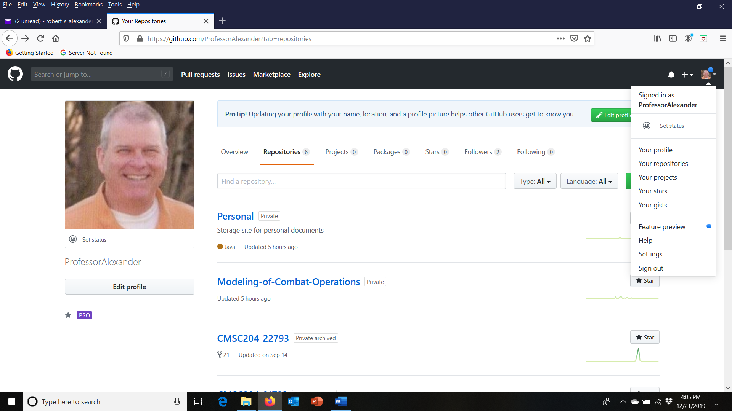

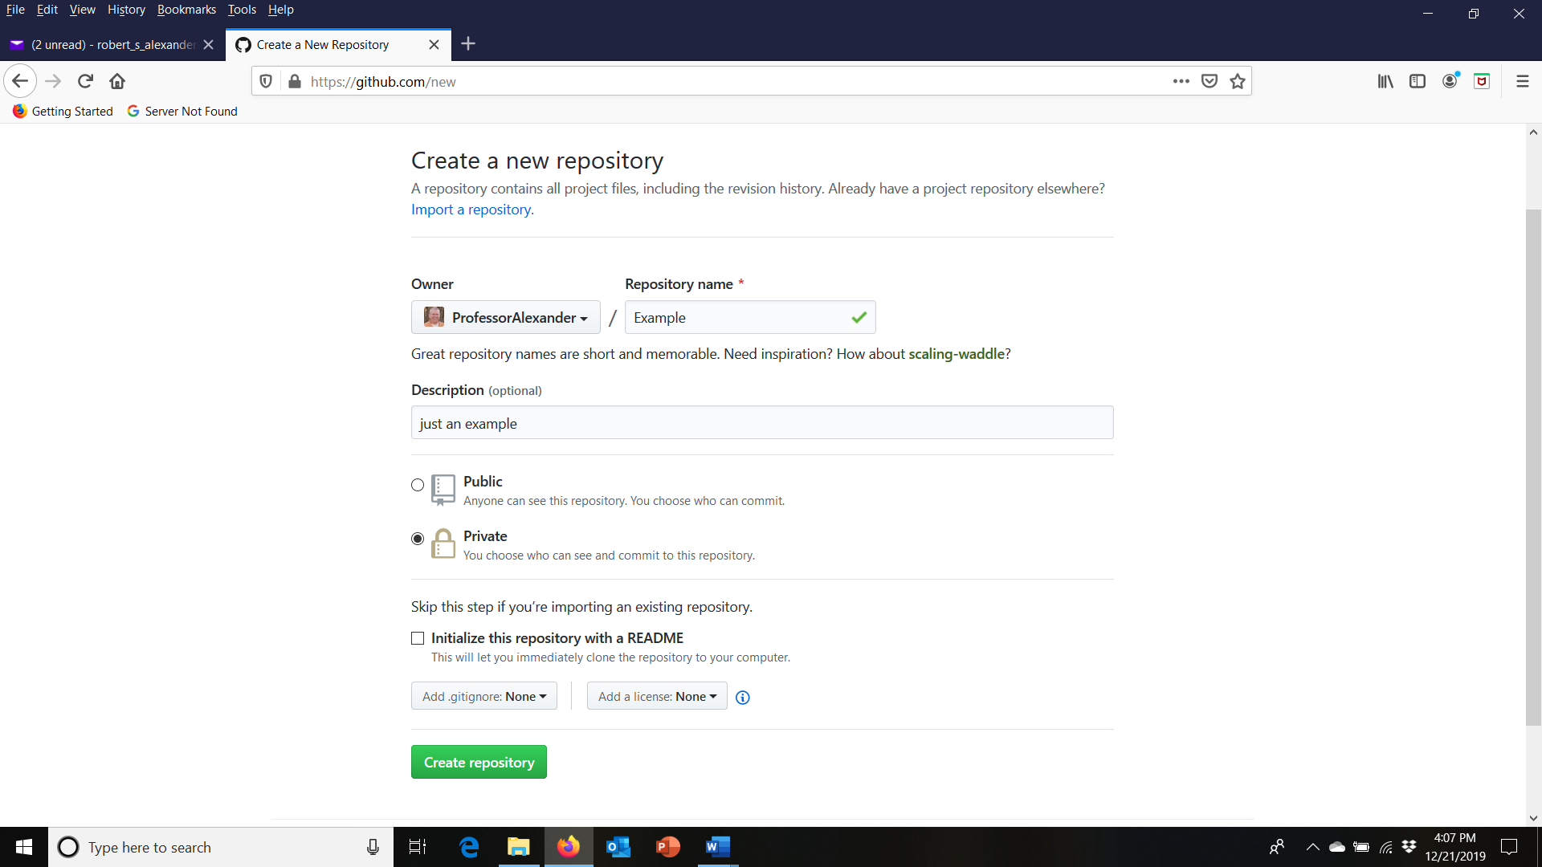

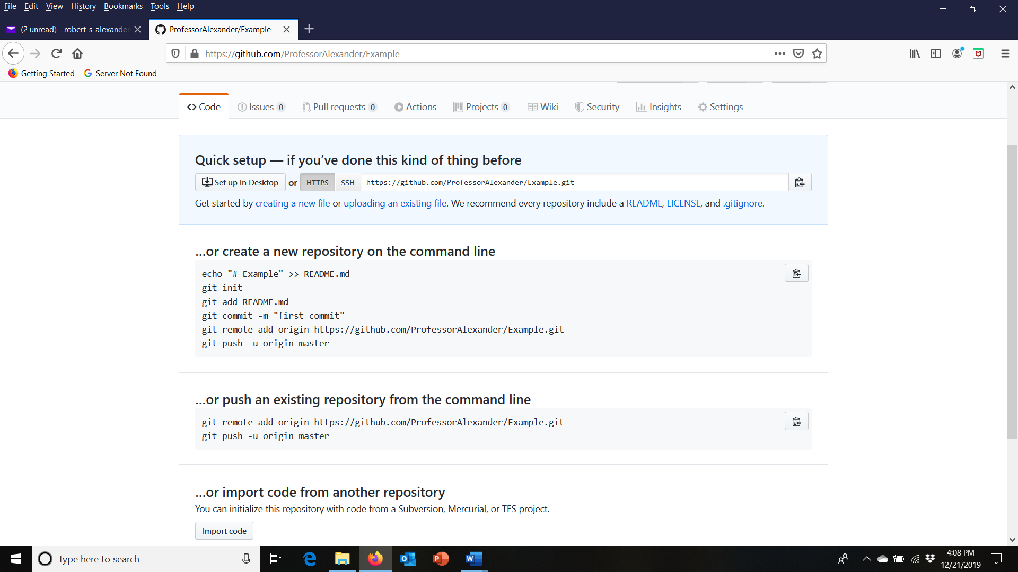

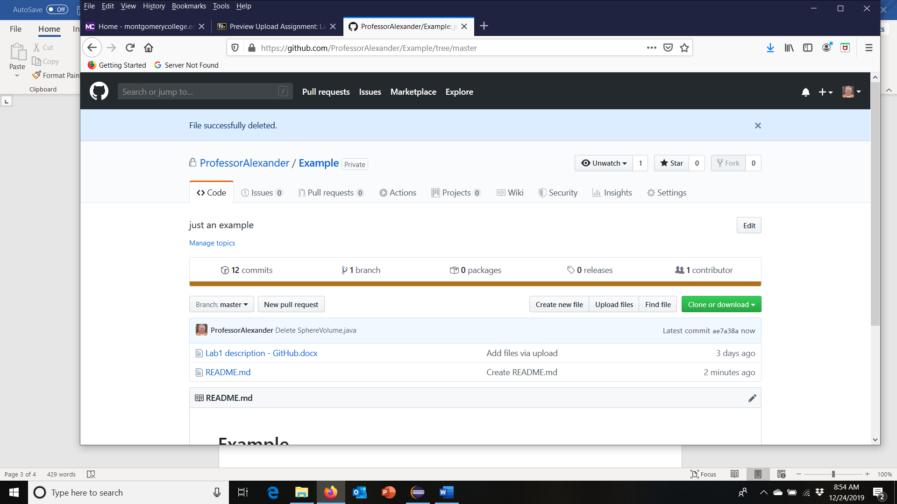

**Task #3 – Take a screen shot of your “Repo”**

Then take a screen shot of your new repository and submit on Blackboard.

**Task #4 – (in the future) Upload Projects**

When you first create the repo, you may upload files by selecting the link and dragging/dropping the directory. Later, you can upload files from the “upload” link in the repo. I recommend selecting the whole directory of your project, so that other projects can exist alongside the earlier ones.

For each programming assignment, upload the files. First, upload the files provided on Blackboard. Then select “commit”. Later you will upload the files you edit. This will avoid losing your files.

**Deliverables**

Your deliverables will be a screen shot of your repository; to be used for programming assignments where you will upload each project’s source codes.

In addition, briefly discuss your learning experience

* What did you learn?
* What issues did you encounter, if any?
* What would you have done differently?
* How can you apply this concept in the future?
* Anything else you would like to share?